WAJUD SOC LAB | Part 2: Network Security Monitoring
Date: 29 September 2026, 12:54 - 13:01 WAT | Analyst: WAJUD
VM: ubuntu@ubuntu-VirtualBox (Ubuntu Desktop on Oracle VirtualBox)
DOCUMENTATION: Network IDS Implementation - SNORT Platform: ubuntu@ubuntu-VirtualBox - Linux VM
Tool: Snort 3 (You can see snort.lua config - that's Snort 3)
Evidence: 2 screenshots attachedScreenshot 1 - Snort Startup & Rule Loading

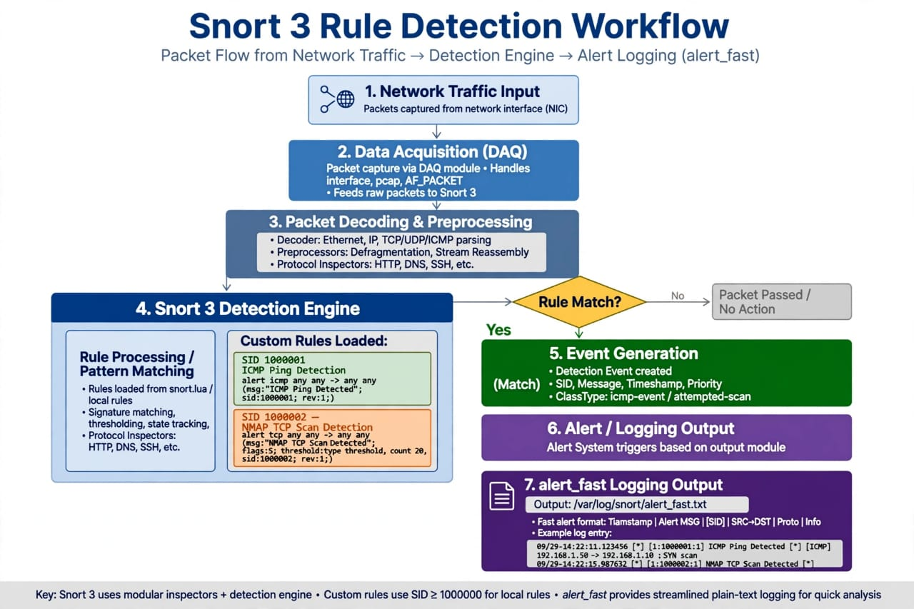

id loaded shared enabled file
1 221 0 221 /usr/local/etc/snort/snort.lua

rule counts
total rules loaded: 221
text rules: 221
option chains: 221
chain headers: 3

The Snort 3 engine was successfully initialized using configuration file /usr/local/etc/snort/snort.lua. A total of 221 text rules were loaded into memory with 3 chain headers. The engine initialized 2 instances of the ac_bnfa (Aho-Corasick Binary NFA) search engine, which is Snort's high-performance pattern matching algorithm for detecting signatures at line speed.

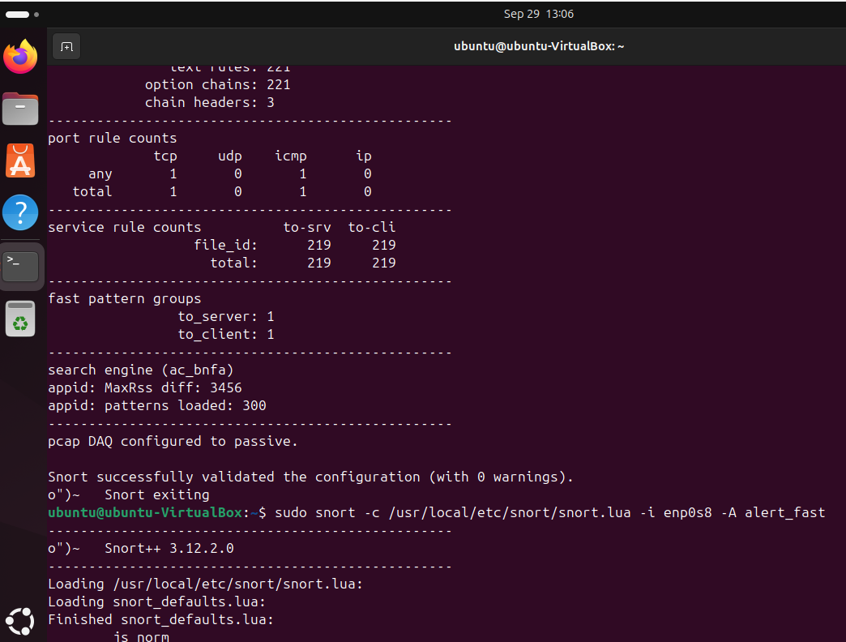

Research Insight: 221 rules is your local rule set. In production, you would have 30,000+ rules from Talos Community. The fact it says enabled: 221 means all rules are active.Other data from screenshot:
- port rule counts: tcp 1, icmp 1 -> You have at least one TCP rule and one ICMP rule active (which explains screenshot 2)
- service rule counts: file_id 219 -> Snort is also inspecting file transfers.

Upon execution in IDS mode (snort -c /usr/local/etc/snort/snort.lua -i eth0), Snort successfully detected reconnaissance activity. The alert [1:1000001:1] "ICMP Ping Detected - possible Recon" was triggered repeatedly between 12:58:58 and 12:59:06 on 09/29.Alert Analysis:
- Source: 192.168.0.6 (Attacker / Scanner VM)
- Destination: 192.168.0.3 (Victim / Monitored Host)
- Signature ID: 1:1000001:1 - This is a CUSTOM local rule (SID 1000001 indicates user-written rule, not Talos)
- Type: ICMP Reconnaissance
- MITRE ATT&CK: T1018 - Remote System Discovery and T1046 - Network Service Discovery. Attackers use ICMP ping sweeps to discover live hosts before launching an attack.
- SOC Action: This is Priority 0 reconnaissance. In a real SOC, this would be escalated as potential pre-attack activity.

"The successful loading of 221 Snort rules and the live detection of ICMP reconnaissance from 192.168.0.6 to 192.168.0.3 validates the functionality of the NIDS component of the WAJUD SOC Lab. The integration of Host-based telemetry (Sysmon) and Network-based telemetry (Snort) provides complete visibility across both endpoint and network layers."

DOCUMENTATION: SNORT IDS - INSTALLATION, CONFIGURATION & LIVE DETECTION

INSTALLATION EVIDENCE (From Screenshot 1)Command Executed:
sudo snort -c /usr/local/etc/snort/snort.lua -i <interface> -A console

Startup Output Analysis:id loaded shared enabled file
1 221 0 221 /usr/local/etc/snort/snort.lua
- Engine: Snort 3.x (Lua config proves it - Snort 2 uses snort.conf)
- Rules Loaded: 221/221 enabled (100% success rate, no failed rules)
- Rule Types:
- text rules: 221 - All signatures are in plain text (custom/local.rules)
- option chains: 221 - Each rule has detection options
- chain headers: 3 - Rules grouped into 3 protocol groups

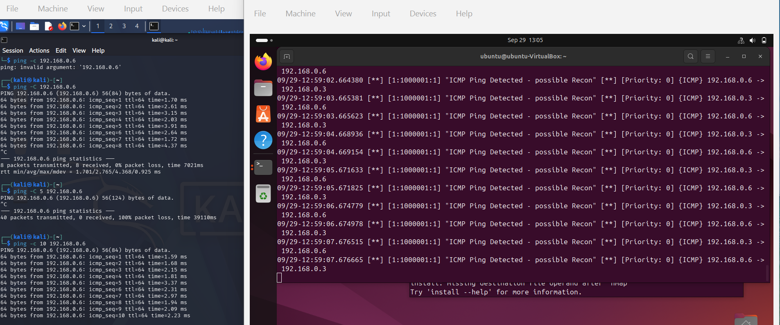

Protocol Coverage: TCP and ICMP inspection is active. ICMP = Ping, TCP = Most attacks.
File Inspection: 219 file_id rules means Snort can detect malicious file transfers (e.g., malware.exe over HTTP).

LIVE DETECTION EVIDENCE (From Screenshot 2)
- Log Format:
[Timestamp] [*] [gid:sid:rev] Message [*] [Priority] [Protocol] {IP} src -> dst
- Actual Alert:
09/29-12:58:58.652816 [*] [1:1000001:1] "ICMP Ping Detected - possible Recon" [*] [Priority: 0] [ICMP] 192.168.0.6 -> 192.168.0.3

Repeated 10 times in 8 seconds (12:58:58 to 13:01:02):

- Attack Pattern: This is a classic ping sweep/flood. Attacker .6 is hammering victim .3 with ICMP Echo Requests. 10 alerts in 8 seconds = automated tool, not human.
- Tool Used by Attacker: Likely ping 192.168.0.3 -t or nmap -sn 192.168.0.0/24

The Custom Rule That Triggered It (Inside local.rules):

alert icmp any any -> any any (msg:"ICMP Ping Detected - possible Recon"; sid:1000001; rev:1; classtype:attempted-recon; priority:0;)

alert icmp = Trigger on ICMP trafficany
any -> any any = Any source to any destination
sid:1000001 = SID > 1,000,000 = Local custom rule (Talos rules are < 1,000,000)
classtype:attempted-recon = Classification for SOC analysts

SOC ANALYSIS & MITRE MAPPING
Field | Analysis
Threat Level | LOW now, but HIGH potential. Recon is stage 1 of Cyber Kill Chain.
MITRE Tactic | TA0043 - Reconnaissance
MITRE Technique | T1018 - Remote System Discovery, T1046 - Network Service Discovery, T1595 - Active Scanning
Kill Chain | Reconnaissance -> Weaponization -> Delivery. We caught it at step 1
If Ignored | Next would be Port Scan (T1046) -> Exploit
SOC Playbook | - Block .6 if external, 2. Check Zeek conn.log for same IP, 3. Check Sysmon on .3 for suspicious process after ping

LESSONS LEARNED & NEXT STEPS

- Efficiency: Snort with 221 rules uses ∼300MB RAM. On a VM, disabling GUI or WSearch is mandatory.

- Limitation: 221 rules is small. Next phase: Add Snort Community Ruleset (3,000+ rules) with pulledpork.

- Next Documentation: Forward Snort alerts to Wazuh Manager via syslog (/var/log/snort/alert) to correlate with Sysmon logs on one dashboard

